Dean Gladish

March 5, 2018

The Romantic Link between Edvard Munch and Francisco Goya

During periods of volatility and struggle, both Munch and Goya were visionaries[1] – they wanted very strongly to portray the need for rationality to be tempered by conscience and vice versa. Romantics at heart[2], they showed their interpretations of reality through Symbolism and outright Propaganda. In this paper I examine *The Scream* and *The Sleep of Reason Produces Monsters* *from the Caprichos*, two Romantic works of art symbolizing the idea that reason and spiritualism must coexist and complement each other in order to foster art and political stability.

*The Scream* symbolizes a precise moment of Munch’s personal experience. Broad brushstrokes and no facial features define an anthropomorphic, twisted figure that screams in agony. He strips all individuality from *The Scream*. Originally calling it *Despair* as part of a series on free love, he painted it as a personal criticism of the Bohemian lifestyle[3]. After rejecting Christian morality for many years[4] Munch wanted to show how jealousies and anxieties can destroy a person who is drawn to a life of sinful expression.

Similarly to Munch, Goya experienced a related form of madness in which visions of giant bats tormented him[5]. His internal anxieties were exacerbated by a sudden and unexplained deafness[6]. *The Sleep of Reason Produces Monsters* is a representation of Goya’s inner state of anxiety about his country. At the time Spain was undergoing political upheaval and oppression on the part of Charles IV and later Napoleon[7]. Goya bridges the gap between the Enlightenment and the Romantic era by portraying himself as the sleeping embodiment of Reason. Like Munch, Goya expressively paints from the imagination – the greyness of the air and the white color of the cat’s eyes, produced by the selective work of acid and protective grain on copper[8], suggest timelessness and his nameless fear of a crumbling society. Edvard Munch’s *The Scream* is a work that also pioneers Expressionism, with wide eyes and a deeply egoistic caricature of a man taking center stage. Taking after the old ideals of Romanticism, Munch portrays reality not as it was but as he personally saw it[9].

The artists convey a pessimistic view of the modern human condition and the progress of the Enlightenment through a universally recognized gesture[10] – both subjects wrap their hands around their heads in defeat. In *The Scream* a bright red, thick and oily sunset suggests existential anxiety brought about by a spiritual vacuum; as the end of Munch’s life approached, his psychology rendered him quite unable to perceive reality[11] and thus stifled his means of understanding the world. Likewise, Goya’s *The Sleep of Reason Produces Monsters* focuses on the limitations of relying on pure reason or pure imagination[12]. The Spanish Inquisition and the reign of Napoleon seemed to prove to Goya that any ideology, whether it is the Enlightenment or organized religion, becomes harmful when reason falls asleep entirely and abdicates responsibility to the forces of the bestial subconscious.

Goya’s work of fantasy was created by a combination of aquatint melting and fine etching[13], and it demonstrates his conviction that fantasy is an essential component of artistic inspiration[14]. The meticulously defined lines, points, and other features stress that reason plays a role even in drawing what are imaginative and fictional figments of emotional turmoil. His engraving, easily reproducible, is essentially a veiled criticism of the monarchy of Charles IV[15]. Altogether he is more optimistic than Munch is about the virtue of conscious thought in its ability to perceive the world.

While Munch’s broad, colorful and simple brushstrokes resemble those of the Impressionists in the style of Van Gogh, Munch is more expressive and colorful than Gogh is. He depicts his own emotions through a vivid distortion of the natural world[16] that draws on Goya’s depiction of a scene that is not faithful to life. *The Scream* brings Munch’s angst and existential terror to the realm of ontology and symbolizes the notion that subjective feeling is just as important and valid as exterior reality. His painting is a reaction to the state of modern man.

The use of linear perspective is quite pronounced in *The Scream*, in which landscapes and people recede into the left side of the painting. Munch’s use of an unprimed canvas[17] allows him to blend colors in order to generate a stylized, surreal and tumultuous psychological exposé. Munch explores themes such as alienation through the black and ill-defined figures in the background as well as the vaguely outlined city. The figure of Munch himself curves with the landscape against the backdrop of a schizophrenic sunset. The clouds are painted as “actual blood” while curving waves of color wash over the reddened landscape[18].

The inscription on the desk in *The Sleep of Reason Produces Monsters* – “the slumber of reason produces monsters[19]” – as well as the reproducible format chosen suggests that Francisco Goya was well acquainted with the propagandist Jacques-Louis David and his *Death of Marat[20]*. However, he seems to suggest that pure reason makes life impossible and that it is inevitable that we embrace imagination as a means of fostering art and good discourse. *The Scream* likewise follows an anti-Naturalist style reminiscent of Van Gogh’s *Starry Night[21]*, suggesting that the Enlightenment has rendered life devoid of all spiritual and moral value. He rejects the Naturalist art style and replaces it with his own Romantic interpretation of life as he witnesses it.

*The Sleep of Reason Produces Monsters* is an allegory of the nightmare that comes about when people forget their original philosophical values of Enlightenment and equality. It hopes to reform a crumbling society through reason[22] rather than through force as Napoleon’s forces later imitate. Goya spoke for the people in the face of the ban of French literature, initiated by Charles IV[23], that set his society back for quite some time. He encourages reform by depicting his own suffering and emotion. Per the Socratic method[24] both artists show specific personal states of the human soul rather than forms and external nature. They illustrate scenes from contemporary life; Munch in particular thought nature and the past to be lifeless[25] and projected his own ego onto the landscape[26] so that he could create a dream-like, Romantic element of despair.

Francisco Goya and Edvard Munch explore themes of de-individualization, timelessness, and a subjective projection of their ego onto a world that warns of the vices of jealousy, immorality, and ignorance. Instead of emphasizing observable reality, they use Symbolist imagery and a uniquely related stylistic vocabulary in order to refine Romanticism by molding nature according to their subjective mood[27]. Munch, for example, portrays things not as they are but as he saw them[28]; his vision of a scream passing through nature can only be depicted best through a simple and highly colorful interpretation. Just like Goya, Munch was a Romanticist who expressed his fears and doubts about the present society’s balance of moral values. In the painting, he turns away from the fjord and focuses directly on the viewer as if to beg for understanding and forgiveness. In this way he encourages the viewer to reflect on their own life. His work commemorates his own life in a way that is accessible to everyone. Thus, both paintings condemn the artists’ irrationality and yet pay homage to the fact that such madness is often the mother of great artworks such as these.

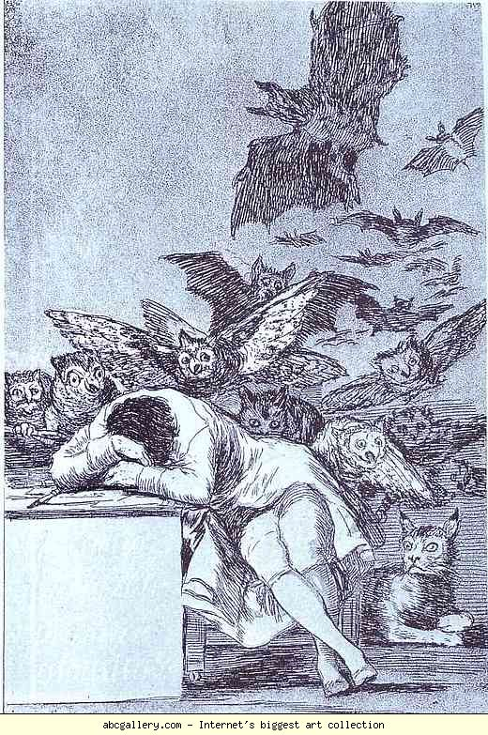

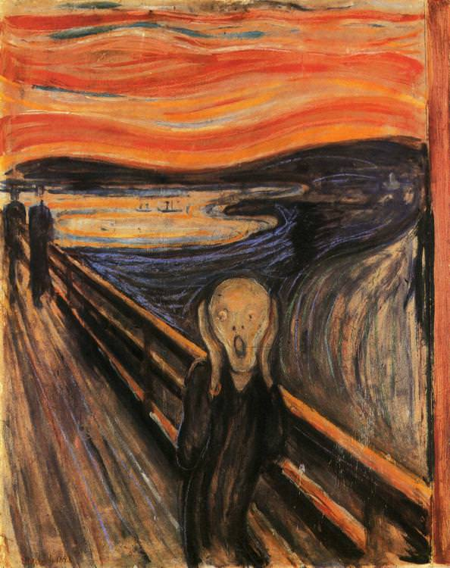 [29]

[30]

Edvard Munch, *The Scream*, 1893. Tempera and oil on unprimed canvas (83.5 x 66 cm). Munch Museum, Oslo.

Francisco Goya, *The Sleep of Reason Produces Monsters*, 1799. Etching and aquatint (21.6 x 15.2 cm). Yale University Art Gallery.

**References:**

Aparicio, Raúl Fernández. *Espacio, Tiempo y Forma* 3 (2015): Saura and Multitudes: From Goya to Munch. DOI: https://doi.org/10.5944/etfvii.3.2015.12699.

Bristow, William. "Enlightenment." Stanford Encyclopedia of Philosophy. August 29, 2017. https://plato.stanford.edu/entries/enlightenment/.

Goya, Francisco. "[Los caprichos]. P. 43, El sueno de la razon produce monstruos." Gallica. January 09, 2012. http://gallica.bnf.fr/ark:/12148/btv1b8451810w/f1.item.r=francisco%20goya%20the%20sleep%20of%20reason%20produces%20monsters.zoom.

Hagen, Rose-Marie, and Rainer Hagen.  *Francisco Goya, 1746-1828*. Köln: Taschen Books, 2003.

Heller, Reinhold.  *Edvard Munch: The Scream*. Edited by John Fleming and Hugh Honour. N. Y., New York: The Viking Press, 1973.

Hull, Anthony. *Goya: Man Among Kings*. Lanham, MD: Hamilton Press, 1987.

Michigan State University. "Francisco Goya, The Sleep of Reason Produces Monsters, c. 1798." Spain: Francisco Goya. April 09, 2016. http://www.abcgallery.com/G/goya/goya135.JPG.

Munch, Edvard. "The Scream, 1893 by Edvard Munch." January 20, 2012. https://www.edvardmunch.org/the-scream.jsp.

Prideaux, Sarah Treverbian. *Aquatint engraving; a chapter in the history of book illustration*. London: Duckworth & Co, 1909.

Stokstad, Marilyn, and Michael W. Cothren. *Art History*. 6th ed. Vol. 2. Upper Saddle River, NJ: Pearson, 2018.

1. Raúl Fernández Aparicio. *Espacio, Tiempo y Forma* 3 (2015): Saura and Multitudes: From Goya to Munch. (DOI: https://doi.org/10.5944/etfvii.3.2015.12699). 111. “Francisco de Goya y Edvard Munch fueron unos visionarios…”
2. Reinhold Heller.  *Edvard Munch: The Scream*. (Edited by John Fleming and Hugh Honour. N. Y., New York: The Viking Press, 1973). 25. “Munch can claim a revival of Romanticism.”
3. Ibid., 36. Munch recognized the weakness of Jaeger’s system of free love – jealousy.
4. Ibid., 35. Munch originally followed Kristiana Bohème, which attacked Christianity, morality, and old legal codes.
5. Rose-Marie and Rainer Hagen.  *Francisco Goya, 1746-1828*. (Köln: Taschen Books, 2003.) 58. “As in the past by giant bats, he was now tormented by visions of torture…”
6. Ibid., 58. Goya’s fears were “heightened by his deafness.”
7. Anthony Hull. *Goya: Man Among Kings*. (Lanham, MD: Hamilton Press, 1987). ix, Foreword. “[Spain] crumbled

   in the 19th century from the shattering impact of the French Revolution and Napoleon.” 100. “These monsters…

   were the blatant evils existing at all levels in the Spain of his day.”
8. Sarah Treverbian Prideaux. *Aquatint engraving; a chapter in the history of book illustration. London: Duckworth & Co, 1909.* 12. “The acid will attack the spaces that separate the particles… “
9. Reinhold Heller.  *Edvard Munch: The Scream*. 39. “I paint, not what I see, but what I saw.”
10. Ibid., 85. The gesture itself even has religious connotations.
11. William Bristow. "Enlightenment." (Stanford Encyclopedia of Philosophy. August 29, 2017). This footnote gives a description of the Enlightenment instead of Munch. By inability to perceive reality, I mean that he is unenlightened in Kant’s sense of an “inability to use one’s own understanding without the guidance of another.”
12. Anthony Hull. *Goya: Man Among Kings*. 100. Goya needed to abandon “‘reason’ to uncover the ‘monsters’…. “
13. Marilyn Stokstad and Michael W. Cothren. *Art History*. (6th ed. Vol. 2. Upper Saddle River, NJ: Pearson, 2018). 957. Description of the etching itself.
14. Anthony Hull. *Goya: Man Among Kings*. 100. “Fantasy deserted by reason produces impossible monsters, but united with it, fantasy is the mother of all the arts and the source of all its wonders.”
15. Ibid., 15. “Goya would have reveled in outrage at the Inquisition…” Politically, Goya aligned himself against the policies of the monarchy to some extent. Thus it makes sense that his engraving is related to his circumstances.
16. Reinhold Heller.  *Edvard Munch: The Scream*. 25-26. “We are never in doubt as to why he paints something. He paints solely what he feels.” 44. Munch “deliberately distorts the features of nature” to express his mood.
17. Marilyn Stokstad and Michael W. Cothren. *Art History*. 1016. Caption next to painting.
18. Marilyn Stokstad and Michael W. Cothren. *Art History*. 1016. “I painted this picture, painted the clouds as actual blood.”
19. Ibid., 957. “El sueño de la razon produce monstrous” is the text inscribed on the etching.
20. Ibid., 953. There are many similarities in the subjects and political motives of these artworks, although one was from France.
21. Ibid., 1013. The colors in Munch’s painting are very similar to the “colored flat shapes, anti-naturalist color, and bold, black outlines” of Van Gogh’s *Starry Night* shown on this page.
22. Ibid., 956. “His goal with [The Caprichos] was to incite action, to alert the Spanish people to see the errors of their foolish ways, and to reawaken them to reason.”
23. Ibid., 956. “Soon after the French Revolution, Charles IV… prohibited the entry of French books into Spain.”
24. Reinhold Heller.  *Edvard Munch: The Scream*. 23. “Socrates already sought to persuade artists to depict the states of the soul rather than just external forms.” Munch’s art is Socratic. I claim that Goya’s is as well.
25. Reinhold Heller.  *Edvard Munch: The Scream*. 23. Nature to Munch is “lifeless.”
26. Ibid., 26. Throughout Munch’s paintings, including one on Loneliness, he likes to “project his own subjective ego into the landscape through the figure.”
27. Ibid., 43. Symbolism is defined as the molding of nature “according to your subjective mood.” Munch does this quite prominently as does Goya in their dramatization of reality.
28. Ibid., 39. He paints not what he sees, but what he saw. His vision is quite colorful and turbulent.
29. Michigan State University, "Francisco Goya, The Sleep of Reason Produces Monsters, c. 1798," (Spain: Francisco Goya, April 09, 2016.)
30. Edvard Munch. "The Scream, 1893 by Edvard Munch." (January 20, 2012).